**Five Scientific Steps to Ace Your Next Exam**

**Optimize your studying and test prep with these techniques.**

Scott Young

Below, I’d like to outline a simple strategy you can use to ace any exam you might have coming up.

Although the specific strategy is my own, the approach is based on cognitive science. In particular, I’m going to look at five key ideas from cognitive science that are easy to miss, but extremely important if you want to study effectively.

**The Strategy to Ace Exams**

**1. When to Study and How Much**

The first question to answer is when you should study and how much.

The obvious answer to this question is that you’ll do better the more you study. If you spend hundreds of hours preparing, you’ll do a lot better than if you spend ten, and you’ll do even better than if you do nothing. This is pretty clear.

What’s less clear is exactly how you should allocate your limited studying time.

This brings us to our first cognitive science principle: [spacing](https://en.wikipedia.org/wiki/Spacing_effect).

The robust literature on the spacing effect clearly shows that studying time is more efficient if it is spread out over multiple sessions than if it is compressed in one session. More exposures to information, separated in time, will result in better retention than if you cram them together in one burst. Therefore, your studying schedule should take whatever time you have available and try to be as evenly spread as possible throughout your semester. It’s natural to study a little bit more right before the exam, but you should do this much less than is typical.

The next question is how much to study each piece of information. Jakub Jilek and I recommend that you [aim for covering each piece of information (via questions or problems) at least five times](https://www.scotthyoung.com/blog/2019/02/15/memory/#spacing), evenly spaced from the time you first encounter them until your eventual testing date. This approach is near-optimal for retaining information with the least amount of effort.

**Advice**: Keep your study schedule evenly spaced out, with only a slight bump right before the test (if at all). Try to practice each piece of info five times from when you first learn it, until your exam.

**2. What to Study and How to Do It**

Once you’ve figured out your schedule, it’s now time to look at what you’re actually doing when you study.

This is a place where there’s a vast gulf between what most students think is effective and what actually works best.

Consider one experiment by psychologists Jeffrey Karpicke and Janelle Blunt. In it, they had students in four groups: single review, repeatedly reviewing the information, free recall of the information (meaning you try to remember as much as you can without looking), and creating a concept map (also called a mind map).

Which do you think best?

Before I answer that, let me tell you what the subjects themselves thought. Those who did a concept mapping and repeated review thought they’d do best, with those doing free recall expecting the worst.

What really happened? The exact opposite. Free recall did much better than the other groups, even though the students themselves expected to score the lowest grades.

This result is just one of many from a broad literature concerning the [testing effect](https://en.wikipedia.org/wiki/Testing_effect). This effect says that testing oneself, so you must retrieve the important information from memory, works better than re-reading notes or creating diagrams while referencing your textbook.

**Advice**: After your first time learning the material, the majority of subsequent studying should be in the form of retrieval practice—trying to reproduce the information, solve a problem or explain an idea—without looking at the source.

**3. What Kinds of Practice to Do**

There’s a strict hierarchy of what kinds of study materials will be most useful to you in preparing for your eventual exam:

1. The most valuable are **mock tests and exams** which are intended to be identical in style and form to the test you’re actually going to take.
2. Next are **problems**, given in homework assignments, textbook questions or quizzes, that are given for your class specifically.
3. Finally, **self-generated questions or writing prompts** based on the material.

Problem sets from other classes often differ a lot in the scope and expectations, so I don’t recommend using them if your goal is to study for a particular exam.

The reason for this hierarchy of practice is known as [transfer-appropriate processing](https://en.wikipedia.org/wiki/Transfer-appropriate_processing). This basically means that the more your practice resembles the exam, the more your practice efforts will transfer into actual results.

If you don’t have access to high-quality problem sets (as is often the case in non-technical classes), a good solution is to do a writing prompt. Pick a concept, theme or big idea and then try to explain it succinctly and accurately without opening the book. Then re-read it to see if you got it right.

**Advice**: Always prioritize higher-quality problem sets. Mock exams are best, followed by in-class problems and then writing prompts from big ideas or concepts discussed.

**4. Make Sure You Really Understand**

Most academic classes are conceptual. This means that passing or failing inevitably rests on whether you understood some important ideas. Memorization matters, but it’s more often as a means to understanding rather than an end in itself.

This means that deeply understanding the core concepts behind any exam you study for should be a top priority.

Practice problems already help with this, since to solve a problem you usually need to understand it.

However, shallow understandings masquerading as deep ones is very common. Psychologists even have a name for this: the illusion of explanatory depth.[[2](https://www.scotthyoung.com/blog/2019/03/18/5-strategies-ace-exam/#2)] The reason is that while it’s easy to self-check factual knowledge (you either know it or you don’t), understanding proceeds in degrees, so it’s easy to convince yourself you know something deeply you don’t.

As a result, I recommend the Feynman Technique as a tool for deepening your understanding of core concepts covered in the class. You’ll know something best when you can teach it.

**Advice**: Identify the core concepts and make sure you can explain them without looking at the material. If you really don’t get something, go back and forth between the explanation in the textbook and your own understanding until you do.

**5. Beat Anxiety by Simulating the Exam First**

Big exams come with big anxiety.

Anxiety is one-two punch for your studying ability. It’s both harder to concentrate and the stress makes it harder to remember things, even if you could.

The solution is to make at least some of your studying sessions a full-blown simulation of the exam. If you have a few mock exams, I would save these for doing a full simulation of the test—same seating posture, materials and, most importantly, the same time constraints.

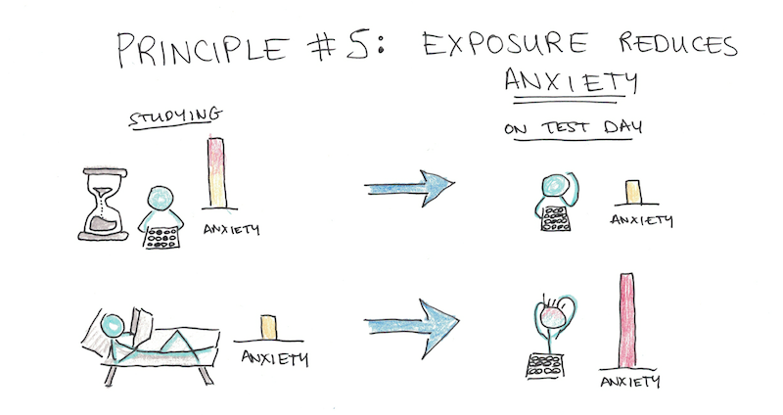

There’s three benefits to doing full simulations:

* You increase your temporary anxiety while studying, which makes it easier to recall the information due to [state-dependent memory effects](https://www.scotthyoung.com/blog/2019/02/15/memory/#state).
* By exposing yourself to the exam situation you’ll be less anxious when the eventual test comes.
* You’ll actually know what your performance is likely to be on the test!

**Advice**: Simulate your exam by doing mock exams (or if you lack those, with other problems) under the same time constraints and conditions of the actual exam.

**Footnotes**

**[1]** – Karpicke, Jeffrey D., and Janell R. Blunt. “Retrieval practice produces more learning than elaborative studying with concept mapping.” *Science* 331, no. 6018 (2011): 772-775.   
**[2]** – Lawson, Rebecca. “The science of cycology: Failures to understand how everyday objects work.” *Memory & cognition* 34, no. 8 (2006): 1667-1675.